JPA Architecture & Entity Lifecycle

What is an Entity?
An Entity is a Java class that represents a table in the database.
Each object of that class represents one row.
But in JPA, an entity is not just a simple object.
Once it is managed, it becomes a tracked object whose changes are automatically synchronized with the database.

Where Spring Data JPA fits
Spring Data JPA is not JPA itself.
It is only a layer on top of JPA that gives us ready-made methods like save(), findById(), delete().
Internally, Spring Data JPA always talks to JPA’s EntityManager.
JPA itself does not talk to the database directly.
It uses Hibernate as its internal implementation.
Hibernate finally uses JDBC to execute SQL.
So the real flow is:
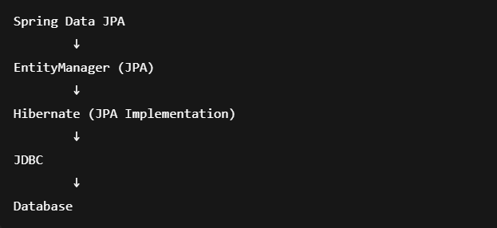

JPA Architecture – The Journey of an Entity

When your application starts, Persistence (configuration) creates an EntityManagerFactory.
This factory is responsible for creating EntityManager objects.

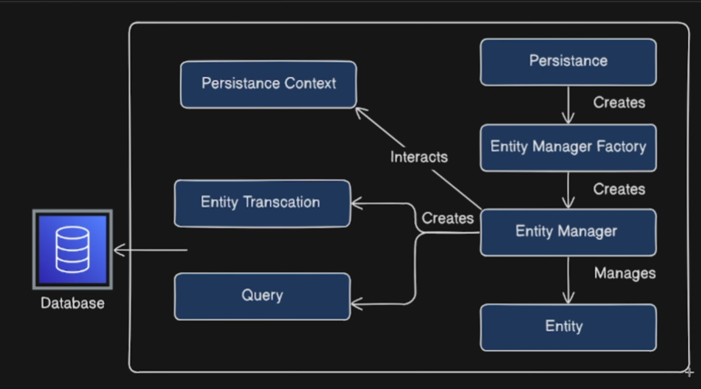

1. Entity Manager – The Controller of Entities
The EntityManager is an interface provided by JPA.
It is responsible for managing the entire life of an entity inside the application.
All operations you perform on an entity are handled by the EntityManager, such as:
- persist() – save
- find() – fetch
- merge() – update
- remove() – delete
- flush() – sync to DB
However, the EntityManager does not talk to the database directly.
It only coordinates and controls what should happen.

2. Entity Manager Factory – Creator of Entity Managers
The EntityManagerFactory is responsible for creating EntityManager instances.
- It is created once at application startup
- It is heavy and expensive
- From this factory, multiple EntityManagers can be created
The factory itself is created by Persistence (configuration).

3. Persistence – The Configuration Layer
Persistence is responsible for:
- Reading DB configuration
- Loading JPA properties
- Creating the EntityManagerFactory
In Spring Boot, this is handled using application.yml / application.properties.
So the startup flow is:
Persistence → EntityManagerFactory → EntityManager

4. Persistence Context – The Memory of JPA
The Persistence Context is an in-memory cache.
It is a temporary storage area where managed entities are kept.
Think of it as a bag of tracked entities.
The EntityManager never works directly on the database first —
it always interacts with the Persistence Context.
EntityManager ↔ Persistence Context
Any entity inside the Persistence Context is called a Managed Entity.

5. Why Entity Manager Cannot Talk to DB Directly
The EntityManager is only an interface (abstraction layer).
It cannot generate SQL or connect to the database by itself.

So it creates:
- Query objects
- EntityTransaction objects
And offloads the real work to its implementation.

6. Hibernate – The JPA Implementation
We already know that Hibernate is the internal implementation of JPA.
So when EntityManager receives a command:
entityManager.persist(entity);
It forwards the request to Hibernate.
Hibernate then:
- Creates HQL
- Converts HQL → SQL
- Sends SQL to the database using JDBC

7. Complete Journey of an Entity
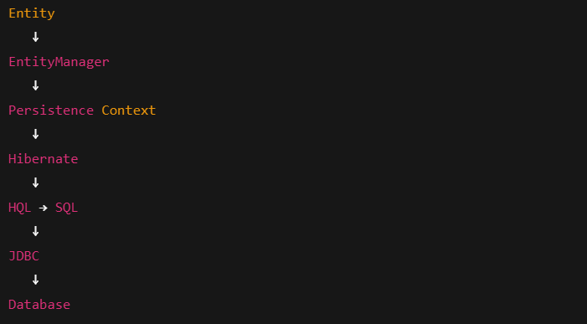This is the real path every entity follows in a Spring Boot application.

Entity Lifecycle – The Movement of an Entity
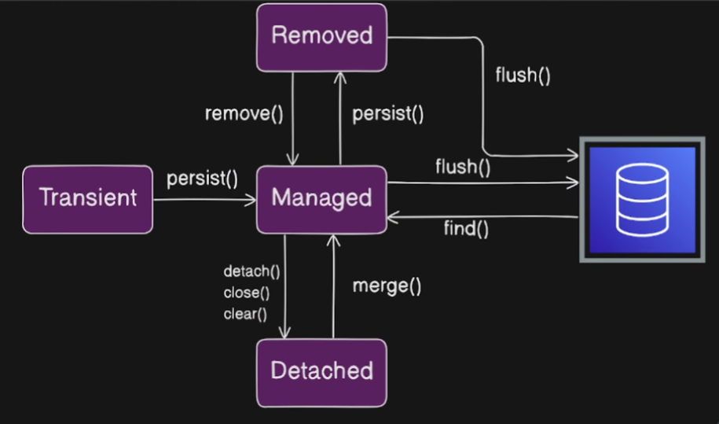
In JPA, every entity object passes through a fixed set of states during its life inside the application.
These states describe how JPA and the EntityManager are controlling that object.
Every entity passes through four states:
1. Transient State – New Object
The moment we create an entity object in our application:
The entity is in the Transient state.
At this stage:
- It is a fresh Java object
- It is NOT managed by the EntityManager
- It is NOT inside the Persistence Context
- It does NOT exist in the database
It is just a normal object in memory.
2. Persist → Managed State
When we call:
The entity moves from Transient → Managed.
Now:
- The entity is controlled by the EntityManager
- It is added into the Persistence Context
- It becomes a tracked object
Once an entity is in the Managed state, any change you make to it is automatically monitored.

3. Managed State – Persistence Context Control
While the entity is managed:
- It is stored inside the Persistence Context
- Entity Manager interacts with the Persistence Context to manage it
- Persistence Context stores all managed entities
This is why JPA can detect changes automatically.

4. Flush → Database Synchronization
When we call:
or when the transaction commits:
- Hibernate generates SQL
- SQL is executed on the database
- Data is saved in the database
Flush means synchronize memory with the database.

5. Find
When we call:
- JPA first checks the Persistence Context
- If not found, it fetches from the database
- The result is added to the Persistence Context
- The entity becomes Managed
6. Detached State
If we call:
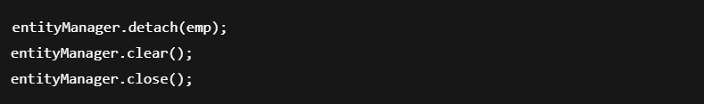The entity moves from Managed → Detached.
Now:
- The entity is no longer tracked
- It was once managed
- Any changes will NOT be synchronized to the database
7. Merge → Back to Managed
To make a detached entity managed again:
The entity moves from Detached → Managed.
8. Removed State
When we call:
The entity moves from Managed → Removed.
It is marked for deletion.
9. Persist Again
The entity moves from Removed → Managed again.

10. Final Delete – Flush
The row is finally deleted from the database.

Lifecycle Flow
